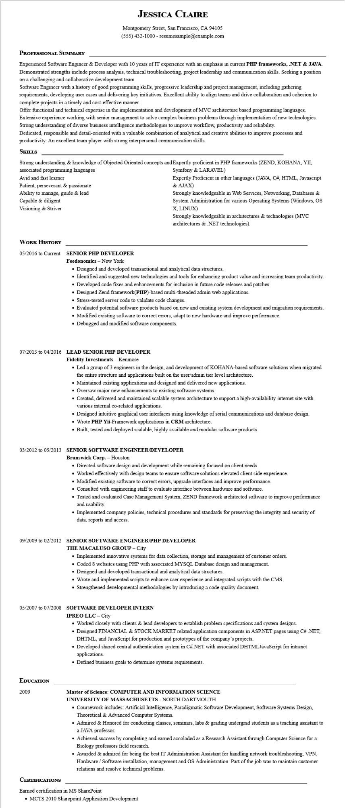
JESSICA CLAIRE
Montgomery Street, San Francisco, CA 94105
(555) 432-1000 - resumesample@example.com
PROFESSIONAL SUMMARY
Experienced Software Engineer & Developer with 10 years of IT experience with an emphasis in current PHP frameworks, .NET & JAVA. Demonstrated strengths include process analysis, technical troubleshooting, project leadership and communication skills. Seeking a position on a challenging and collaborative development team.
Software Engineer with a history of good programming skills, progressive leadership and project management, including gathering requirements, developing user cases and delivering key initiatives. Excellent ability to align teams and drive collaboration and cohesion to complete projects in a timely and cost-effective manner.
Offer functional and technical expertise in the implementation and development of MVC architecture based programming languages. Extensive experience working with senior management to solve complex business problems through implementation of new technologies. Strong understanding of diverse business intelligence methodologies to improve workflow, productivity and reliability.
Dedicated, responsible and detail-oriented with a valuable combination of analytical and creative abilities to improve processes and productivity. An excellent team player with strong interpersonal communication skills.
SKILLS
Strong understanding & knowledge of Objected Oriented concepts and Expertly proficient in PHP frameworks (ZEND, KOHANA, YII,
associated programming languages
Avid and fast learner
Patient, perseverant & passionate
Ability to manage, guide & lead
Capable & diligent
Visioning & Striver
Symfony & LARAVEL)
Expertly Proficient in other languages (JAVA, C#, HTML, Javascript & AJAX)
Strongly knowledgeable in Web Services, Networking, Databases & System Administration for various Operating Systems (Windows, OS X, LINUX)
Strongly knowledgeable in architectures & technologies (MVC architectures & .NET technologies).
WORK HISTORY
05/2016 to Current
SENIOR PHP DEVELOPER
Feedonomics - New York
• Designed and developed transactional and analytical data structures.
• Identified and suggested new technologies and tools for enhancing product value and increasing team productivity.
• Developed code fixes and enhancements for inclusion in future code releases and patches.
• Designed Zend framework(PHP)-based multi-threaded admin web applications.
• Stress-tested server code to validate code changes.
• Evaluated potential software products based on new and existing system development and migration requirements.
• Modified existing software to correct errors, adapt to new hardware and improve performance.
• Debugged and modified software components.
07/2013 to 04/2016 LEAD SENIOR PHP DEVELOPER Fidelity Investments - Kenmore
• Led a group of 3 engineers in the design, and development of KOHANA-based software solutions when migrated the entire structure and applications built on the user/admin tier level architecture.
• Maintained existing applications and designed and delivered new applications.
• Oversaw major new enhancements to existing software systems.
• Created, delivered and maintained scalable system architecture to support a high-availability internet site with various internal co-related applications.
• Designed intuitive graphical user interfaces using knowledge of serial communications and database design.
• Wrote PHP Yii-Framework applications in CRM architecture.
• Built, tested and deployed scalable, highly available and modular software products.
03/2012 to 05/2013 SENIOR SOFTWARE ENGINEER/DEVELOPER
Brunswick Corp. - Houston
• Directed software design and development while remaining focused on client needs.
• Worked effectively with design teams to ensure software solutions elevated client side experience.
• Modified existing software to correct errors, upgrade interfaces and improve performance.
• Consulted with engineering staff to evaluate interface between hardware and software.
• Tested and evaluated Case Management System, ZEND framework architected software to improve performance and usability.
• Implemented company policies, technical procedures and standards for preserving the integrity and security of data, reports and access.
09/2009 to 02/2012 SENIOR SOFTWARE ENGINEER/PHP DEVELOPER
THE MACALUSO GROUP - City
• Implemented innovative systems for data collection, storage and management of customer orders.
• Coded 8 websites using PHP with associated MYSQL Database design and management.
• Designed and developed transactional and analytical data structures.
• Wrote and implemented scripts to enhance user experience and integrated scripts with the CMS.
• Strengthened developmental methodologies by introducing a code quality document.
05/2007 to 07/2008 SOFTWARE DEVELOPER INTERN
IPREO LLC - City
• Worked closely with clients & lead developers to establish problem specifications and system designs.
• Designed FINANCIAL & STOCK MARKET related application components in ASP.NET pages using C# .NET, DHTML, and JavaScript for production and prototypes of the company's projects.
• Developed shared central authentication system in C#.NET with associated DHTML JavaScript for intranet applications.
• Defined business goals to determine systems requirements.
EDUCATION
2009
Master of Science: COMPUTER AND INFORMATION SCIENCE UNIVERSITY OF MASSACHUSETTS - NORTH DARTMOUTH
• Coursework includes: Artificial Intelligence, Paradigmatic Software Development, Software Systems Design, Theoretical & Advanced Computer Systems.
• Admired & Honored for conducting classes, seminars, labs & grading undergrad students as a teaching assistant to a JAVA professor.
• Achieved success by completing and earned accoladed as a Research Assistant through Computer Science for a Biology professors field research.
• Awarded & admired for being the best IT Administration Assistant for handling network troubleshooting, VPN, Hardware/Software installation, management and OS Administration. Part of the job was to maintain customer relations and resolve technical problems.
CERTIFICATIONS
Earned certification in MS SharePoint
• MCTS 2010 Sharepoint Application Development

